**LOAD FLOW ANALYSIS IN NETWORK**

**1)**

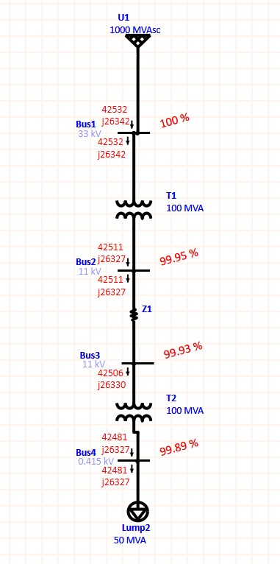

**ETAP SIMULATION**

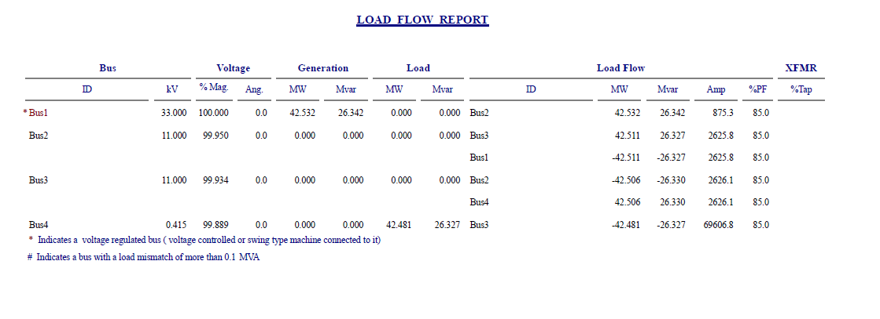

**LOAD FLOW REPORT**

**2)**

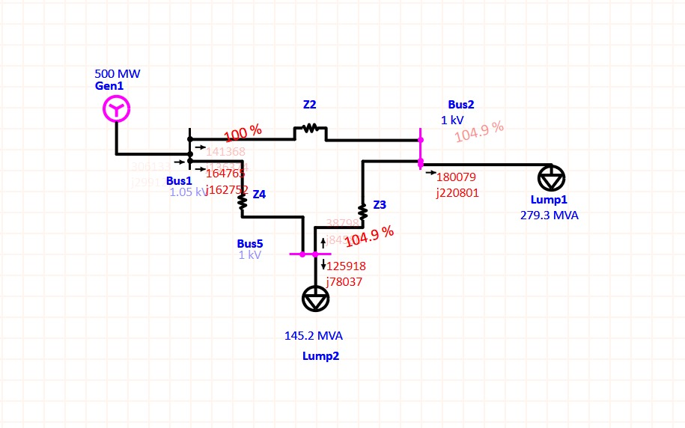

**ETAP SIMULATION**

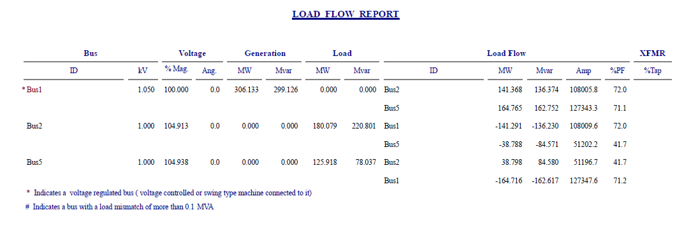

**LOAD FLOW REPORT**

**3)** 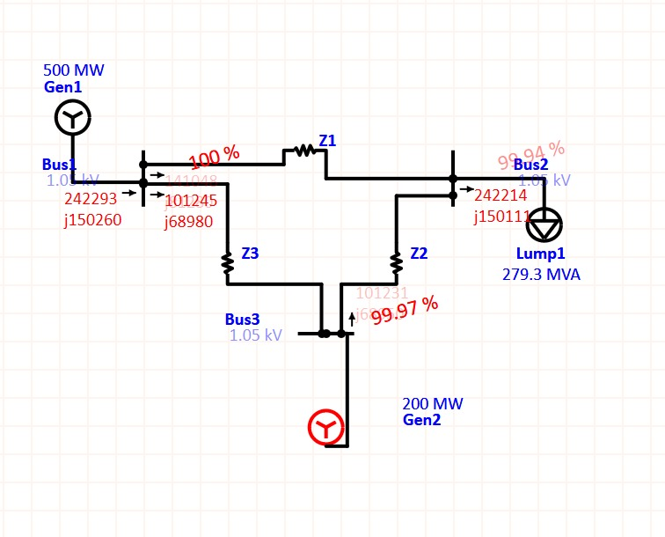

**ETAP SIMULATION**

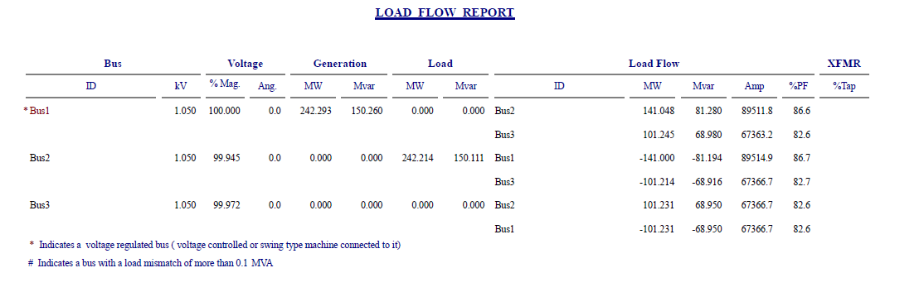

**LOAD FLOW REPORT**